12-DECEMBER-2021

Group Members

Name: Umair, Sidra Perveen

Roll No: Bscs2019, Bscs201935

Submitted to: Dr Junaid.

Artificial Intelligence

Report of Artificial Neural Networks.

**Abstract**

Scikit-learn (Sklearn) is the most valuable and powerful library for AI in Python. It gives a choice of productive devices for AI and factual demonstrating including order, relapse, bunching and dimensionality decrease through a consistence interface in Python. Scikit-learn is used because it’s basic and productive instrument for prescient information investigation, available to everyone, and reusable in different settings. It is based on NumPy, SciPy, and matplotlib while it’s also open source and monetarily usable.

**Content**

*What is Neural Networks? ------------------------------------------------------------------------------------------2*

*What is Artificial Neural Networks? ------------------------------------------------------------------------------2*

*Role of Neural Network in AI ---------------------------------------------------------------------------------------3*

## *Use Neural Network in Artificial Intelligence -------------------------------------------------------------------3*

## *Requirement for Neural Networks -------------------------------------------------------------------------------3*

## *Working of Artificial Neural Networks --------------------------------------------------------------------------3*

## *Weaknesses of Neural Networks---------------------------------------------------------------------------------4*

### *Scope of Artificial Intelligence Neural Networks-------------------------------------------------------------4*

**What is Neural Networks?**

A neural network is a progression of algorithms that undertakes to perceive hidden connections in a bunch of information through a cycle that mirrors the manner in which the human mind works. In this sense, neural organizations allude to frameworks of neurons, either natural or fake in nature. A neural network is an illustration of AI, where programming can change as it figures out how to tackle an issue.

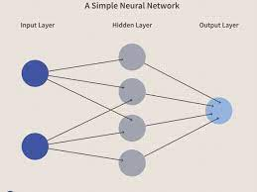

Neural networks mirror the conduct of the human brain, permitting PC projects to perceive designs and tackle normal issues in the fields of AI and profound learning. A neural organization is a worked on model of the manner in which the human mind processes data. It works by recreating an enormous number of interconnected handling units that look like theoretical forms of neurons.

**What is Artificial Neural Networks?**

Artificial Neural Network is a kind of neural organization which depends on a Feed-Forward technique. Artificial neural networks are the center apparatuses of AI. These are machines shaped by the disclosure of neuron operationally in the mind, which will recreate the same way we people learn. Neural organizations is comprised of both the info and result layers and furthermore a secret layer containing units that change input data into yield activity so the result layer can deal with the worth. These are the instruments for recognizing designs; they are different and muddled and generally just for software engineers to recuperate and create.

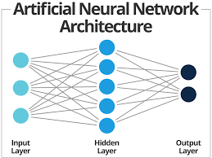

**Role of Neural Network in AI:**

Primary point of neural networks is to tackle complex issues like example acknowledgment or facial acknowledgment, and a few different applications incorporate, discourse to-message record, information examination, penmanship acknowledgment for actually look at handling, climate forecast, and sign handling.

## Use Neural Network in Artificial Intelligence:

## Numerous undertaking applications and business organizations utilize these advancements. Their chief reason for existing is to determine muddled issues like example recognizable proof or facial ID and different applications including discourse to-message, information examination, record, penmanship ID for confirming cycles, climate conjecture, and sign handling

## Requirement for Neural Networks:

## Neural networks have a unimaginable capacity to recuperate significant information from broken information and is utilized in perceiving the floats and concentrate designs that are intricate to appreciate by people as much as machines. A gifted neural network can turn into a specialist in the information that has been given to analyze and can be utilized to deliver forecasts.

## Working of Artificial Neural Networks:

## An Artificial Neural Network holds an immense measure of processors working relating, organized in layers. The underlying layer gathers the crude information as info, as old as natural eye optical optic nerves. Each nonstop layer gets the crude info information as result from the former layer, which acts the same way as neurons of the optic nerve acquiring signals from neighboring nerves. The last layer then, at that point, gives the result.

## C:\Users\Dell Pc\Pictures\Working-principle-of-an-artificial-neuron-Artificial-neural-network-ANN-22-is-a.ppm.png

## Neural networks are adaptable. They can change themselves as per the guidance and work corresponding to give more data about the climate. In the event that the framework shapes the pined for yield, then, at that point, there is no necessity to alter the per-arranged information as well as the other way around. Assuming the framework delivers an accidental result finishing off with blunders, the framework changes the prepared info information to refine the results.

## Weaknesses of Neural Networks:

## From a mechanical discernment, perhaps the greatest disadvantage is the measure of time it requests to show organizations, which regularly need a sufficient measure of figuring power for muddled assignments. The following greatest issue is that neural organizations show their reaction as far as neuron loads and actuation. It is hard to discover the thinking behind their decisions. To that end they are regularly called secret elements. This makes it difficult to decide out assuming that they are giving decisions dependent on wrong conditions. Not at all like the human psyche, which can perform assignments with few models, neural organizations require large number of guides to perform. Scientists are steadily dealing with these limits.

### **Scope of Artificial Intelligence Neural Networks:**

Being essential for a very aspiring society, we get an opportunity to accomplish much more from neural networks. Their capacity to learn through models propels them, making them solid and dynamic. Moreover, we don't need to concoct a calculation to do a given task.

We needn't bother with any interior instruments for the assignment. These are appropriate for constant administrations as they react quickly with superb computation times as they work with equal designs. The most engaging trait of neural organizations is that there is a likelihood that some time or another clever organizations may radiate better outcomes. As per a few researchers, care is a power-driven property, and responsive neural organizations are down to earth and in all probability feasible. Neural organizations have a huge capacity. We can get the best from them by conniving with figuring, AI and ML.

Without a doubt, additional astonishing revelations are coming later on. To venture into this promising vocation and become a specialist in Artificial Intelligence, then, at that point, check the internet based Artificial Intelligence course. This will assist you with accomplishing flawlessness in this field soon.

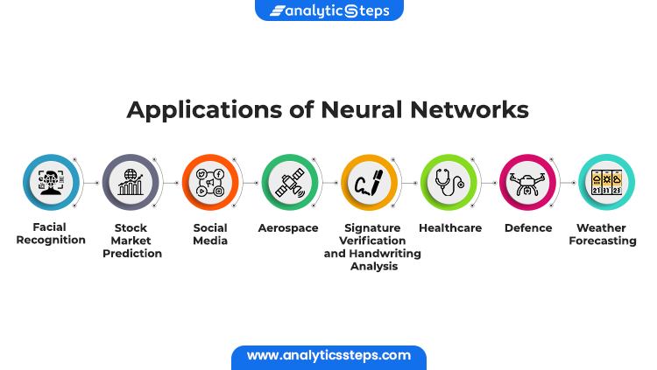

******

## Experiments and results:

So at first without features extraction the accuracy was 0.13594581519109822. Which means it was 13% on training data.

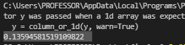

After adding the features, the accuracy on training data is Accuracy: 0.7319787131107885 but I also added the hidden layers to (500, 500, 500) and max_iter = 500



I did some changes in hidden layer and max_iter and everytime I changed the values of hidden layer and max_iter, the accuracy is also changed.

Now performing the model on test data. The accuracy is low. Here is the screenshot.

